Dhanasekaran S
Dhanasekaran S | Mobile : +91 9500693283
Java Developer & AWS solutions architect | dhans0504@gmail.com

OBJECTIVE
Highly self-motivated and sort time goal-oriented professional committed to pursuing a long-term career as a Java developer. With years of track record demonstrating strong analytical and problem solving skills, computer proficiency and ability to follow through with projects.
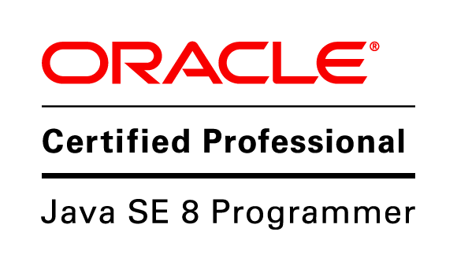
PROFILE
Having 4.6 years of experience in the Java based web application development and also have experience across the full system development lifecycle.

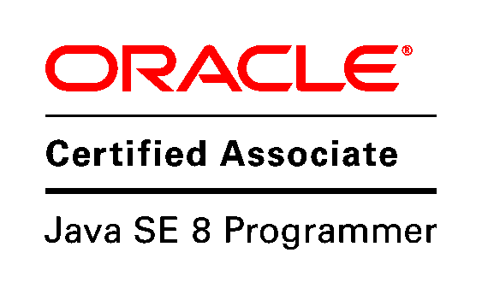
ROLES AND RESPONSIBLITIES SUMMARY
- Designing the DB structure
- Implementing the JSF pages, Service layer, Data layer
- Writing Stored procedure
- Developing the micro services
- Synching the data with salesforce using soap web services

EDUCATION
BE in Electrical and Electronics Engineering - 7.21GPA | 2013
Anna University of Technology, Trichy
Higher secondary – 90.33% | 2009
Malar Matriculation Higher Secondary School, Namakkal
SSLC – 86%
Government Higher Secondary School, Palapatti, Namakkal | 2007
EXPERIENCE
Company: Revature | Feb 2015 – Till date
Designation: Senior Software Engineer
Place: Chennai
Product: Revature
Revature Pro is an online Internship platform that provides training for students in USA and also provides placement opportunities for the students. It provides online training and boot-camp/ in-house training for its students. Many top companies made Revature Pro as its corporate training partner and many universities had a tie-up with Revature Pro to use the syllabus as part of their academic curriculum.
The training related content created in Admin Module which is the backbone of the training and the content created are used by the students and this module is named as Front-end. The Users can create their Portfolios after completion of their projects to showcase to the employers and get high chances of employment opportunities
For Revature Pro, AWS Cloud for EC-2 is used as the web application hosting server, S3 is used as the storage for documents and RDS is used for MySQL database.
Key Responsibilities
- Migrated old DB structure to newer structure.
- Designing the Database.

Core Competence

Certifications



Languages
Java
PL/SQL
JavaScript
jQuery

RDBMS
Oracle 9i
MySQL 5.6

Technologies
J2EE
JSON
AJAX
HTML5
CSS3
Bootstrap
XML

Frameworks
JSF
Spring boot
Spring core
Struts 2.x
AngularJS

ORM
Hibernate

Web/App servers
Tomcat
Apache
JBoss (Wildfly)

Web services
REST
SOAP

ORM
Hibernate

Operating Systems
Windows
Cent OS
- Tuning the SQL queries and xhtml pages.
- Writing small procedure to avoid multiple time DB hitting.
- Developing the micro services using spring boot application.

Technologies
Java 1.8,JSF 2.2, Spring 4.1, Spring boot 1.5.6, Hibernate 4.1, MySQL 5.6, Apache 2.4, Tomcat 8, AngularJS 1.3,Gradle, Git

Company: Gatt systems | Apr 2013 – Feb 2015
Designation: Software Engineer
Place: Chennai.
Product: CricWay | Mar 2014 – Feb 2015
CricWay is a cricket scoring and news web application exclusively for the game of cricket. It features news, articles, and live scorecards.

Key Responsibilities
- Solely Responsible for analyzing, designing the DB structure.
- Developing and implementing the JSF pages for several modules.
- Developing and implementing the service layer, JSF bean layer and DAO layer for several modules.
- Tuning the XHTML pages and SQL queries for several modules.

Technologies
Java 1.7, JSF 2.0, Spring 3, Hibernate 4.1, MySQL 5.5, Tomcat 7,Prime Faces, Maven, Git

Project: Student Management System | Nov 2013 – Feb 2014
Student Management System is for maintaining student information and to create reports on monthly cycle. The application is also used to mail the reports to the manager.

Key Responsibilities
- Solely Responsible for analyzing, designing the DB structure.
- Developing and implementing the JSF pages for several modules.
- Developing and implementing the service layer, JSF bean layer and DAO layer for several modules.
- Tuning the XHTML pages and SQL queries for several modules.

Technologies
Java 1.7, JSF 2.0, Spring 3, Hibernate 4, MySQL 5.5, Tomcat 7,Prime Faces, Maven

Project: OOAI VM | Apr 2013 – Sep 2013
OOAI VM is a vendor management application where different client request would be allocated to different vendors. Vendor allocation and its post processes would be handled and maintained with this application

Key Responsibilities
- Developing and implementing the JSF pages for several modules.
- Developing and implementing the service layer, JSF bean layer for several modules.
Build tools
MAVEN
GRADLE

Version control
Git
cvs



Technologies
Java 1.7, JSF 2.0, Spring 3, Hibernate 4, MySQL 5.5, Tomcat 7,Prime Faces, Maven

PERSONAL DETAILS

Date of Birth : 05–Apr-1992
Sex : Male
Mother Tongue : Tamil
Marital status : Single
Nationality : Indian
Languages Known : Tamil & English
Passport : Available
Address : 17, 2nd floor, Chelliamman Street, Velachery, Chennai- 600042

